LAB 5: STRINGS IN JAVA

Name: Shreyas Sawant Div: D7A Roll No.: 55

Q.1 Write a program to find a particular character on the given index. Take index from user.

CODE:

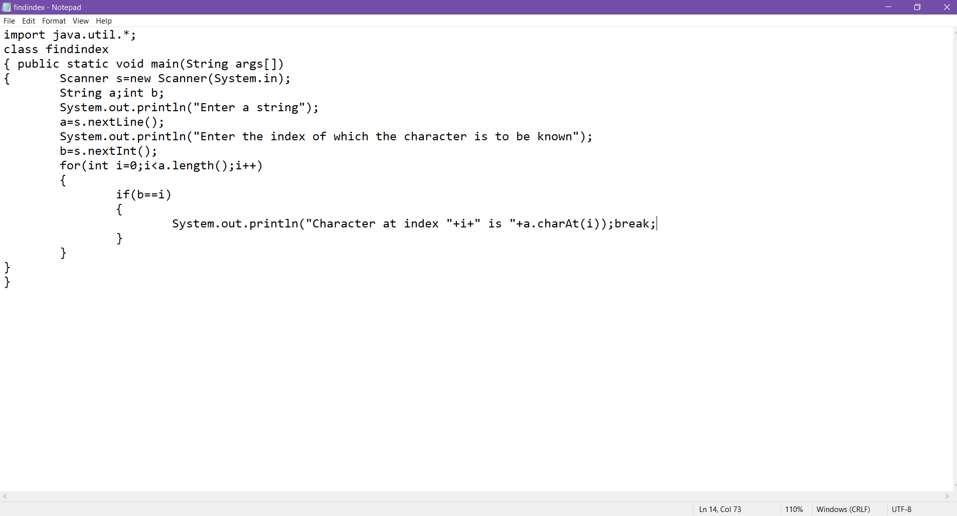OUTPUT:

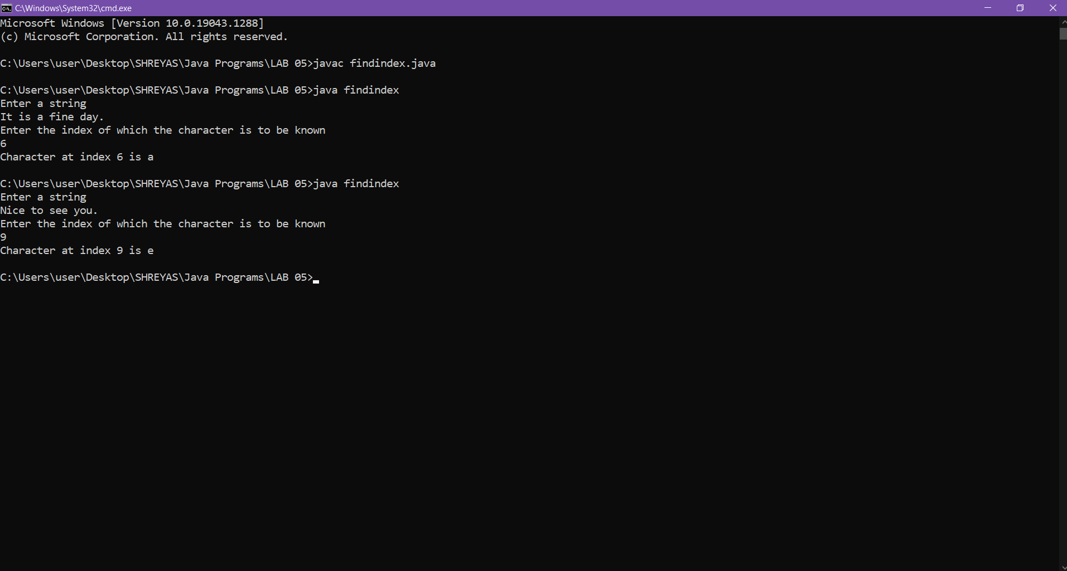

Q.2 Write a program to reverse the string.

CODE:

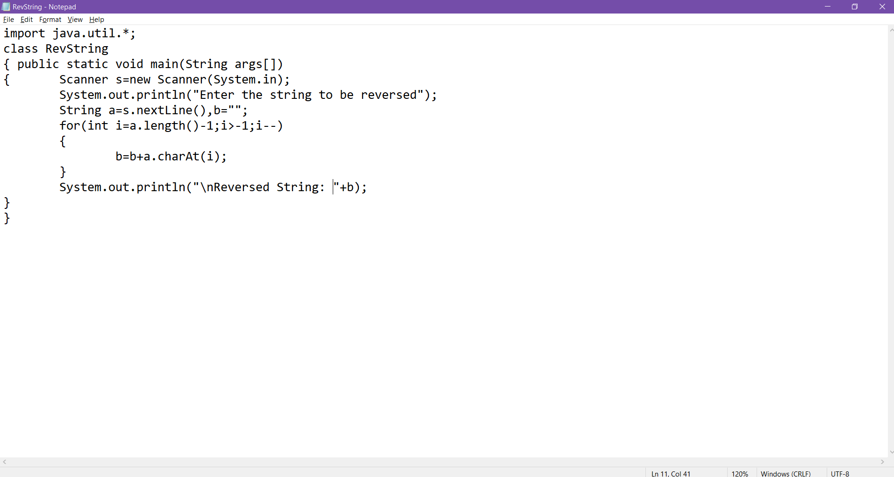

OUTPUT:

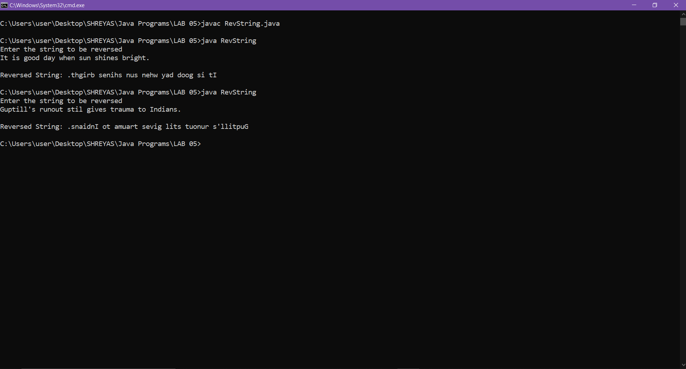

Q.3 Write a program to check if the given string is palindrome or not.

CODE:

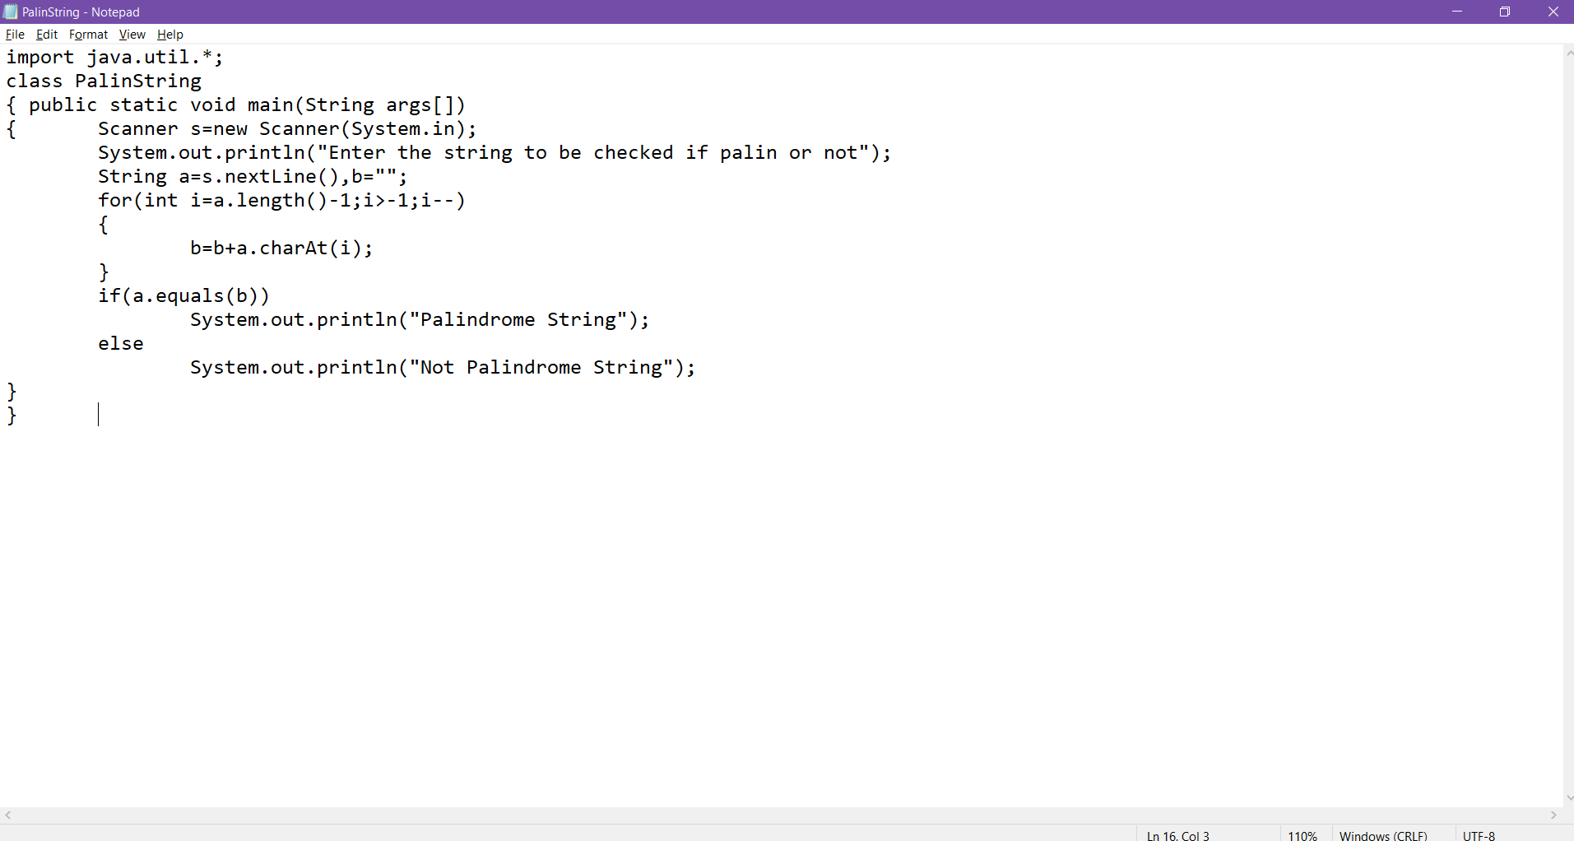

OUTPUT:

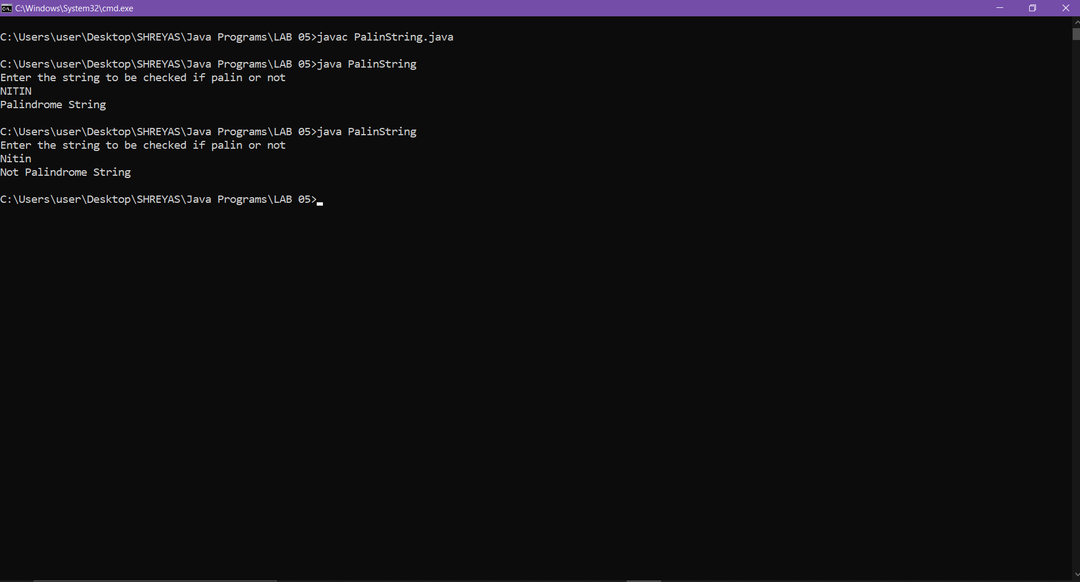

Q.4 Write a program to convert starting letter of each word in a long string to uppercase.

CODE:

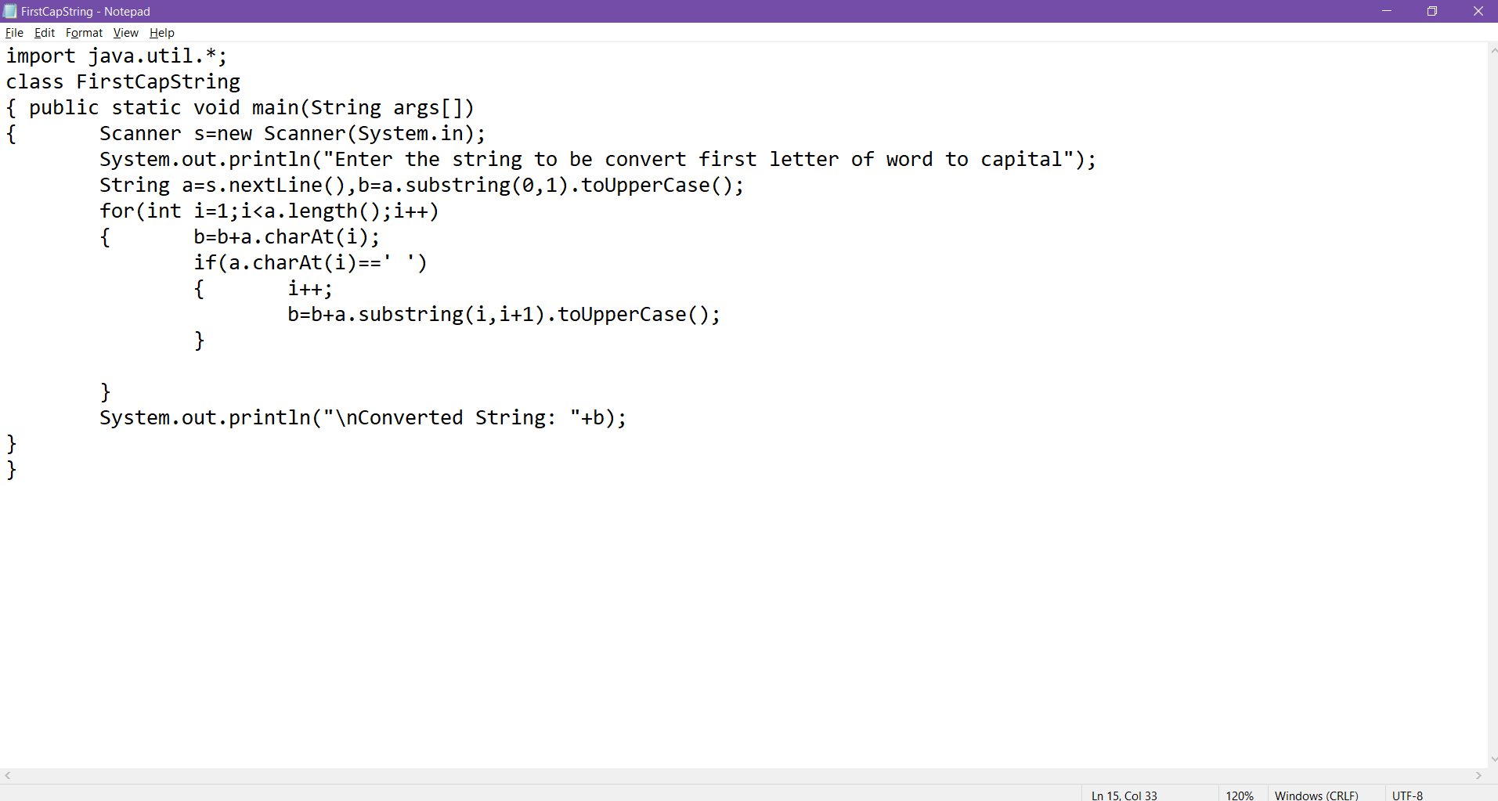

OUTPUT:

